

**Derivative and Options Pricing 40.242**

**Group Assignment 1**

**MSCI Mauritius Hedge Report**

**Group 4 Members:**

Praveen Rajesh (1004322)

Dody Senputra (1004335)

Nicholas Tan Yi Da (1004126)

Noel Tan Heng Kiat (1004136)

Edric Tjandra (1004306)

**Executive Summary**

We firstly did an in-depth analysis on MSCI Mauritius and found out it has only 2 companies within the index (a banking firm and a retail-focused real estate investment company) with heavy weightage (81.41%) on the financial sector with rest on real estate sector. To hedge MSCI Mauritius spot prices, we needed to identify index futures with similar and reasonably explained exposure such that basis risk is reduced, and overall portfolio value is preserved while minimising overall negative returns.

Using data from the Bloomberg Terminal which reveal the industry and country attribution of several MSCI indices, we identified three “Generic 1st” futures to short hedge with: **MSCI Emerging Markets Financials Index Futures** (HJR1), **MSCI Qatar Index Futures** (ZRD1), **MSCI Emerging Markets Index Futures** (ZTS1). We pursued a short hedge strategy, as our qualitative analysis, we hypothesized a positive price movement correlation between futures and spot prices.

During data collection, we realised that price data for some days were missing for some futures contracts, which could be due to public holidays in which there were no trading activity, or simply due to a low trading interest in those contracts. Hence, we extrapolated the missing data using the 3-day moving average.

For the naïve hedge simulation, we found out that overall portfolio value with the 3 different futures went positive in the end from 1/1/2021 to 31/12/2021. Analysis of standard deviation of return for each portfolio revealed that HJR1 was the most effective futures to short, while ZRD1 was the least effective.

For the optimal hedge simulation, we used linear regression technique to obtain the hedge ratio for each futures contract. We found that ZRD1 produced the most effective hedge with the lowest standard deviation of returns. HJR1 was deemed the best hedge by the naïve simulation but was the worst performing with the optimal hedging strategy.

In conclusion, we have proven that the optimal hedging strategy performed better than the naïve hedging strategy and we would short 681 ZRD1 contracts to hedge our $100m-MSCI-Mauritius-tracking portfolio.

**Analysis Task 1**

MSCI Mauritius Index has 81.41% weightage in a banking firm with the remaining weightage in a retail-focused real estate investment firm. A brief description of the 2 companies is as follows:

* **MCB Group Limited** is a financial service holding company. It’s headquartered in Port Louis, Mauritius, with subsidiaries and investments in Mauritius, France, India, Madagascar, Maldives, Mayotte, Mozambique, Réunion, Seychelles, and South Africa.
* **Lighthouse Properties** is a real estate investment firm that invests predominantly in Western European markets such as the UK, France, and Portugal, with a focus on retail real estate assets such as shopping malls.

To protect against a price decrease of the MSCI Mauritius Index, we decided on a short hedge strategy by choosing futures of indices with a similar sector composition, as there were no futures contracts available for the MSCI Mauritius Index.

Choice 1: MSCI Emerging Markets Financials Index Futures (HJR1)

HJR1 has a very high weightage on banking firms at 74.83%, predominantly from emerging markets such as India, China, and Taiwan. Both indices have a high weightage on banking firms and the MCB group also has a strong presence in multiple emerging markets. We believe that their movements in the spot and futures prices would be similar, which is beneficial in reducing basis risk and increasing correlation.

Choice 2: MSCI Qatar Index Futures (ZRD1)

ZRD1 has a very high weightage on the financial sector at 67.95%, with 40% of the weightage accorded to Qatar National Bank alone. Like MCB group, the Qatar National Bank also has high exposure to emerging markets such as Indonesia, Egypt, and Tunisia. ZRD1 also has limited exposure to real estate at 2.81%. We believe this strengthens the correlation between the MSCI Mauritius and Qatar indices. Both indices are heavily exposed to emerging markets through their respective financial sectors, and we believe this could reduce the basis risk and increase correlation in futures and spot prices.

Choice 3: MSCI Emerging Markets Index Futures (ZTS1)

ZTS1 has a similar country attribution to HJR1, but the industry weightages are more diversified and includes sectors such as information technology (21.8%) and financials (20.96%). As MCB group is heavily invested in several emerging markets, they are highly likely to be exposed to a plethora of industries as well. Thus, we believe that the futures and spot prices would have similar price movements, resulting in lower basis risk and high correlation.

|  |  |
| --- | --- |
| **Data Task 1** | **Data Task 2** |
|  |  |
|  |  |
|  |  |

**Data Task 3**

There were some missing price data for the selected futures, which could have occurred due to being public holidays where there is no trading activity.

We used the average price of the previous 3 days to calculate the missing price data for the day. The assumptions are:

1. Low price volatility of selected futures
2. Future prices can be reasonably predicted with historical price data (average of rolling window period) with low errors

**Data Task 4 (Source: Bloomberg Terminal)**

|  |  |  |  |
| --- | --- | --- | --- |
| Futures | No. of Contracts (Naive Hedging) | Contract Size | Contract Value (At 1st Jan 2021) |
| HJR1 | 4114 | 50 x Contract Price | $24,306 |
| ZRD1 | 6715 | 10 x Index | $14,890 |
| ZTS1 | 1614 | $100 x Index | $61,930 |

**Data Task 5**

|  |  |
| --- | --- |
|  |  |
|  |  |
|  |  |

**Data Task 6**

|  |  |  |
| --- | --- | --- |
| Futures | Arithmetic Average Returns | Standard Deviation |
| HJR1 | 0.001164003 | 0.01486075 |
| ZRD1 | 0.001193332 | 0.016853382 |
| ZTS1 | 0.001264824 | 0.01981787 |

Best Contract for Hedge: **HJR1** (lowest standard deviation of AAR)

Worst Contract for Hedge: **ZTS1** (highest standard deviation of AAR)

**Analysis Task 2**

We believe the difference in the hedged portfolio returns of the best and worst hedging instruments can be explained by the difference in the composition of the indices used to hedge against MSCI Mauritius and their sensitivity to systematic shocks to events in 2021.

The portfolio with the HJR1 futures performed best as both the MSCI Mauritius and the HJR1 have a high attribution to the financial sector. Moreover, the financial sectors in both indices were heavily exposed to emerging markets. As the financial sector is highly interlinked at the global level, we think that most emerging markets would have reacted similarly to global systematic shocks, such as recessions in 2021 due to COVID infection waves. Hence, we theorize that both indices would have responded with similar price movements in such events.

The portfolio with the ZTS1 futures performed worst. Although Mauritius is an emerging market as well, ZTS1 has China as its heaviest country weightage and IT as its heaviest industry weightage (instead of financials). This may result in a less than an ideal correlation between the spot price changes of the Mauritius index and the futures price of MSCI Emerging Markets Futures. Hence, this difference in price sensitivity likely resulted in ZTS1 being the worst short hedge option.

**Data Task 7**

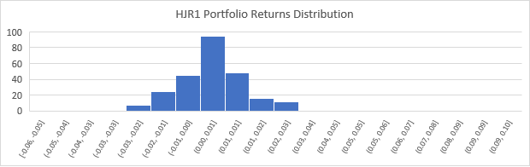

|  |  |  |
| --- | --- | --- |
| Top 3 poorest performing days for HJR1 portfolio: | | |
| Rank | Date | Returns |
| 1 | 29/11/2021 | -0.059245016 |
| 2 | 20/07/2021 | -0.058075145 |
| 3 | 15/03/2021 | -0.046995395 |

**Analysis Task 3**

Since we were pursuing a short hedge strategy, the portfolios experienced negative returns when:

1. the spot prices of the MSCI Mauritius Index decrease more than the futures prices of HJR1
2. the spot prices of the MSCI Mauritius Index increase less than the futures prices of HJR1

In the 3 poorest performing days, both spot and futures prices decreased due to negative systematic shocks. Across all 3 dates, there were either announcements of new COVID variants or anticipation of interest rate hikes. Noticeably, MCB group suffered large losses on all 3 days, contributing to the overall price drop of the MSCI Mauritius Index. In contrast, the stock price for Lighthouse Properties did not move as much on those 3 days – in fact, the price of Lighthouse Properties shares increased on 29th November. However, news on these 2 companies was not attainable from Bloomberg or other sources. We will attempt to explain the poorest returns through our own independent analysis.

For 15th March 2021, there could have been an “anxious” market sentiment which awaited the upcoming Federal Reserve board meeting on 17th March on the issue of interest rate policy, which resulted in a small sell off in the market on market opening on 15th March. MCB group stock prices dropped in response to the global sell off.

On 20th July 2021, concerns over rising COVID-19 cases due to the “Delta” variant led to a steep drop in major benchmarks like Nasdaq and S&P 500 (David, 2021). Both the spot and futures prices decreased due to this global systematic shock. However, HJR1 was better diversified across several markets, whereas MSCI Mauritius was exposed to Mauritius only. Hence, we theorize that MSCI Mauritius Index has a higher beta risk to the global market price movements (such as the S&P 500 Index) and experienced a larger price drop than HJR1.

The returns on 29th November 2021 were affected by the news of emergence of the “Omicron” COVID variant in South Africa. With renewed COVID worries, there was yet another drop in major indices such as the S&P 500 and Dow Jones, as well as a drop in oil prices (Schroder, 2021). Banks and travel companies experienced the heaviest losses in the indices (Schroder, 2021), as investors forecasted reduced economic activity if case numbers were to rise again. Both the spot and futures prices decreased due to this global systematic shock. Since the Mauritius Index is highly weighted on MCB Group, we theorise that MSCI Mauritius Index suffered heavier losses due to a higher beta risk to the financial sector than HJR1.

Across all 3 dates, Lighthouse Properties did not experience as much price movements. This could be due to the real estate sector having a low beta risk to the global market. Hence, the price decrease of MCB Group can be attributed to the spot price decreasing more than the futures price of HJR1. In addition, MCB Group also delivered poorer-than-expected news on quarterly financial calls in November, which saw an increase in contingent liabilities, cost-to-income ratio, and operating expenses. There were no investor articles to confirm this, but we believe the bleak financial call could have led to reduced confidence from investors in MCB Group. Hence, the poor financial outlook of MCB, in addition to fears brought by new COVID variants led to the spot prices of MSCI Mauritius to decrease more than the futures prices of HJR1.

**Data Task 8**

The h is estimated with 20-month (8th Apr 2019 to 31st Dec 2020) worth of price data. The positive value means that the position of the futures should be different of the spot, in this scenario, we must short the hedge.

|  |  |  |  |  |  |  |  |
| --- | --- | --- | --- | --- | --- | --- | --- |
| Futures | Hedge ratio, h | | R2 | p-value for hedge ratio | No. of Contracts (Optimal Hedging) | Contract Size | Contract Value (At 1st Jan 2021) |
| HJR1 | 0.564821265 | 0.044288114 | | 6.2594E-6  99% Confidence Interval | 2324 | 50 x Contract Price | $24,306 |
| ZRD1 | 0.101460873 | 0.020356001 | | 0.00233571  99% Confidence Interval | 681 | 10 x Index | $14,890 |
| ZTS1 | 0.148329223 | 0.00581569 | | 0.10501907  90% Confidence Interval | 240 | $100 x Index | $61,930 |

**Data Task 9**

|  |  |  |
| --- | --- | --- |
| Futures | Arithmetic Average Returns | Standard Deviation |
| HJR1 | 0.001135392 | 0.012700151 |
| ZRD1 | 0.001123633 | 0.011650163 |
| ZTS1 | 0.001131951 | 0.012443384 |

Best Contract for Hedge: **ZRD1** (lowest standard deviation of AAR)

Worst Contract for Hedge: **HJR1** (highest standard deviation of AAR)

**Analysis Task 4**

While HJR1 has very huge exposure to financials, especially banks, it is still mainly concentrated within the Chinese market which might not have high correlation with financials of other smaller emerging markets like Mauritius. The index also does not have exposure to real estate unlike the Mauritius Index, which may have ultimately led to a lower-than-expected hedge effectiveness and low correlation between Chinese financials and smaller emerging market financials.

On the other hand, ZRD1, with Qatar National Bank as its biggest component of the index, has multiple presence in smaller emerging markets like MCB group, along with a small exposure in real estate. We theorise this might explain ZRD1 performing the best out of the 3 futures with similar geographical financials exposure as well as real estate hedge.

**Data Task 10**

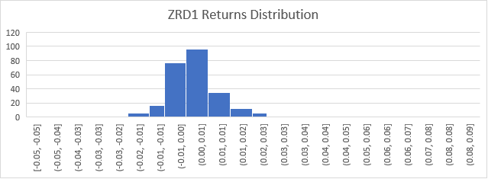

|  |  |  |
| --- | --- | --- |
| Top 3 poorest performing days for ZRD1 portfolio | | |
| **Rank** | **Date** | **Returns** |
| 1 | 20/7/2021 | -0.051594872 |
| 2 | 29/11/2021 | -0.042741382 |
| 3 | 15/03/2021 | -0.03825914 |

**Analysis Task 5**

Similar to Analysis Task 3, the portfolios experienced negative returns when:

* the spot prices of the MSCI Mauritius Index decrease more than the futures prices of ZRD1
* the spot prices of the MSCI Mauritius Index increase less than the futures prices of ZRD1

The 3 poorest performing days for the optimal hedge coincided with the worst performing days of the naïve hedge. Across all 3 dates, there were announcements of new COVID variants that led investors to fear that global economic recovery would be slowed down. Thus, we theorise that the high attribution of MCB group in the Mauritius Index, together with the banking sector having a high beta risk to the global market caused the spot price to decrease more than the ZRD1 futures prices on all 3 occasions amidst global sell offs.

Across all 3 dates, Lighthouse Properties did not experience as much price movements. We think this could be due to the real estate sector having a low beta risk to the global market. Hence, the price decrease of MCB Group alone can be attributed to the spot price decreasing more than the futures price of ZRD1. Hence, the poor financial outlook of MCB, in addition to high beta risk of MCB Group to the global market led to the spot prices of MSCI Mauritius to decrease more than the futures prices of ZRD1, resulting in a few of the worst negative returns.

**Analysis Task 6**

Observing our hedges, HJR1 did the best when it came to naive dollar matching strategy, but it performed the worst in the optimal hedging strategy. In comparison, ZRD1 resulting in the most effective hedge using the optimal hedging strategy.

When we compare both strategies, all 3 portfolios using the optimal hedging strategy had a lower standard deviation of realised returns than the best performing portfolio using the naive hedge strategy (HJR1, 0.01486075).

As such, all the portfolios using the optimal hedge strategy performed better than the naïve hedge strategy, with ZRD1 from Data Task 9 being the most effectively hedged portfolio. Naïve hedging assumes both spot and future prices move in the same direction and magnitude. However, since the spot is hedged using assets with a different country and industry attribution, this is a risky assumption. This strategy should only be used if price data is unavailable.

Since the futures and spot prices data was available, our analysis revealed that the spot and futures prices moved differently since the underlying assets in the futures indices were not the same as the spot asset. Optimal hedging takes that into account by generating the hedge ratio through regression analysis of spot and future price changes, to find the appropriate optimal number of future contracts to be used for hedging. This strategy produces a more effective hedge than the naïve strategy, as proven by the lower standard deviation of returns across all optimal hedge portfolios.

**Appendix**

Future Contract Specifications (Source: Bloomberg Terminal)

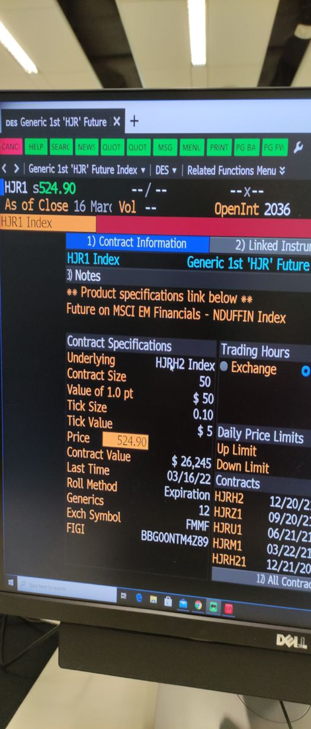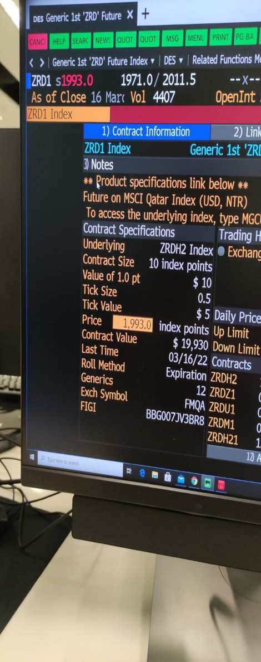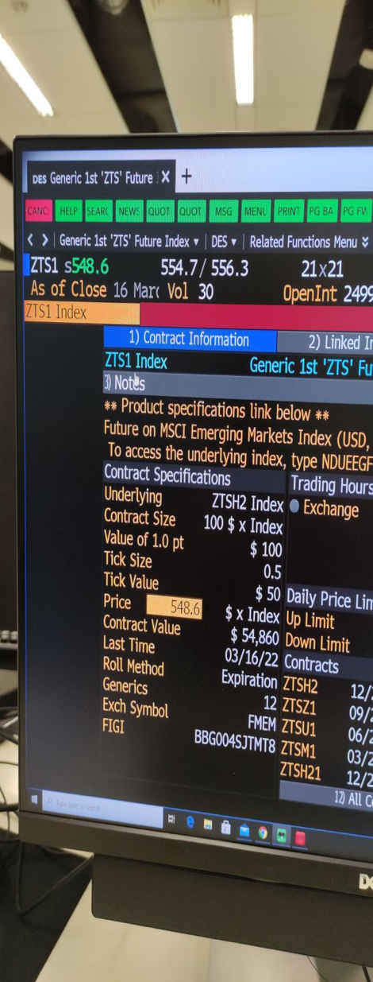

**References:**

1. MSCI. (n.d.). *MSCI MAURATIUS FACTSHEET*. MSCI. Retrieved March 20, 2022, from <https://www.msci.com/documents/10199/87550624-b75c-4b24-817d-6003de17d5ec>
2. MSCI. (n.d.-b). *MSCI QATAR FACTSHEET*. Retrieved March 20, 2022, from <https://www.msci.com/documents/10199/cd4c3955-b178-4ff5-9d08-a8f73229328f>
3. MSCI. (n.d.-a). *MSCI EMERGING MARKETS FACTSHEET*. Retrieved March 20, 2022, from <https://www.msci.com/documents/10199/c0db0a48-01f2-4ba9-ad01-226fd5678111>
4. Yahoo News. (2021, July 20). *Stock market news live updates: Stocks suffer biggest drop in months as rising COVID cases shake confidence*. Sg.news.yahoo.com. <https://sg.news.yahoo.com/stock-market-news-live-updates-july-19-2021-221841943-111046902.html>
5. MSCI. (n.d.-c). *MSCI EMERGING MARKETS FINANCIALS FACTSHEET*. Retrieved March 20, 2022, from <https://www.msci.com/documents/10199/8b5ce0be-61d4-4e30-9b6d-d4b9eed53f08>
6. Schroeder, P. (2021, November 19). Safe havens surge, oil sinks as investor seek COVID respite. *Reuters*. <https://www.reuters.com/markets/europe/global-markets-wrapup-3-pix-2021-11-19/>
7. Qatar National Bank. (n.d.). *QNB at a glance Factsheet*. QNB. Retrieved March 20, 2022, from <https://www.qnb.com/sites/qnb/qnbqatar/page/en/enfactsheet.html#:~:text=Qatar%20National%20Bank%20(Q.P.S.C.),by%20members%20of%20the%20public>.
8. Cox, J. (2021, March 17). *Fed sees stronger economy and higher inflation, but no rate hikes*. CNBC. <https://www.cnbc.com/2021/03/17/fed-decision-march-2021-fed-sees-stronger-economy-higher-inflation-but-no-rate-hikes.html>
9. Lighthouse Properties. (n.d.). *PORTFOLIO*. Lighthouse Properties P.l.c. Retrieved March 20, 2022, from <https://www.lighthousepropertiesplc.mt/portfolio/>
10. MCB Group. (n.d.). *MCB Group | Company Profile*. Mcbgroup.com. Retrieved March 20, 2022, from <https://www.mcbgroup.com/en/company-profile>